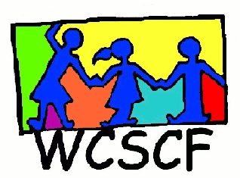
Hout Bay Forum Meeting Minutes
28th JUNE 2021 @ 13h00
on Zoom
____________________________________________________________________________________________________________________________

PRESENT: Janice King (WCSCF), Rushni Collins ( WCSCF Coordinator), Shelli Marx (Health Forum, Shawco), Jana (James’ House), Natasha Smith (DSD Metro South)
APOLOGIES: Tjarla Norton (Community Cook Up), Jeanine Swile (DSD Metro South)

AGENDA TOPIC | DISCUSSION | ACTION TO BE TAKEN
- WELCOME, INTRODUCTIONS | Janice welcomed all.  Presentation by Eddie Hendricks on the Reconnect Development youth organisation  Reconnect Slide Show Attached
- Adoption of Previous Minutes | Only 3 member and WCSCF staff attended
- Shelli Marx: Health Forum Shawco | Shelli expressed that she found the presentation helpful.  Hout Bay schools could benefit and maybe Eddie could train some Hout Bay staff to do the programme  Family was referred to DSD and Shelli wanted some feedback on how far he process is.
- Natascha Smith  DSD Metro South | Natascha part of the Hout Bay team, standing in for Janine while on leave  Previously over saw the Hout Bay area currently works in the Parkwood area  Regarding the family that was referred: Ashraf was the intake worker. Doesn’t have the status of the case but will check and let Shelli know  Ashraf is leaving DSD, Leaving Natasha, Janine and 2 Auxiliary workers  Janine to get back from leave on July 1st  Natascha interested in Reconnect Development youth as she works in the Parkwood area as well | Natascha to get back to Shelli on status of the case
- Jana (James House Social Worker) | Jana interested in the Reconnect Development Youth Programme.  Will speak to supervisor and make contact with Eddie  Not much change regarding the children and programme in the area | Jana to make contact with Eddie Hendricks.
- Other: | None
- Next meeting | Date: TBC
 | Meeting adjourned.

Enquiries: Janice King (WCSCF Director Operations)
Cell: 072 4500 456 Email: wcstreetchild@gmail.com

