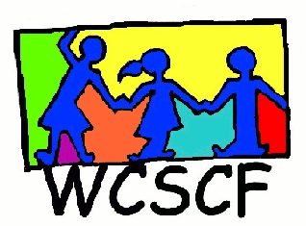
Northern Suburbs Street Children’s Meeting
12th April 2018
9:00 – 12:00
Durbanville Council Chambers
__________________________________________________________________________________
Present:
Apologies: None

- Welcome and introductions. Janice welcomed everyone

- Next meeting: 31 May 2018

Enquiries: Janice King (Coordinator)
Cell: 072 4500 456
Email: wcstreetchild@gmail.com

