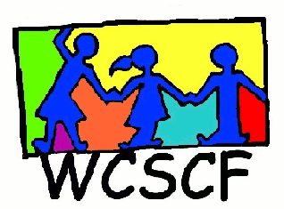
SPECIAL ALL REGIONS MEETING MINUTES (Constitution change)
13th November 2019
SALESIANS INSTITUTE
10:00-12:00
______________________________________________________________________________

PRESENT: Allistair Scholtz (VRCID), Cheryl Harper (We Can Change), Sandy Harper (We Can Change), Bijou Bako (EL THEOS), Mia Coetzee (WCSCF), Wilma Piek (VRCID), Alois Aloo (SOS), Elizabeth Horn (KRAC), Sharon Cloete (BTLC/KSS), Demelia Swartz (Badisa Scottsdene), Amber- Rose Potter (Badisa Scottsdene), Xavier Mutabane (VCC), Valencia Lottriet (VCC), Berenice Blaauw (VCC), Monica woodhouse (GIVE A CHILD A FAMILY), Colleen Brookes-Gain (WCSCF),Charlene Moses (MPC), Janice King (WCSCF).

APOLOGIES: Pat Eddy (CCID), Stacey Doorly-Jones (STAND), Misquah (Justice Desk)
______________________________________________________________________________

- COFFEE AND NETWORKING

- WELCOME and INTRODUCTIONS: Janice welcomed everyone and introductions went around the room.

- TAX EXEMPTION AMENDMENTS TO THE CONSTITUTION
The Coordinator explained the changes that had been made to the WCSCF Constitution, being those being those required by law in order to become a Public Benefit Organisation (PBO) with Tax Exemption. The new wording was read out to the meeting, after which voting around the changes was done.
- There were no objections to the changes to the WCSCF Constitution.
- Berenice accepted changes and Wilma seconded the changes.
Changes in Point 5 of the Constitution – Management Changes
- Berenice accepted the changes and Wilma seconded the changes.
The changes to the WCSCF Constitution have been ratified.

- GUEST SPEAKER:
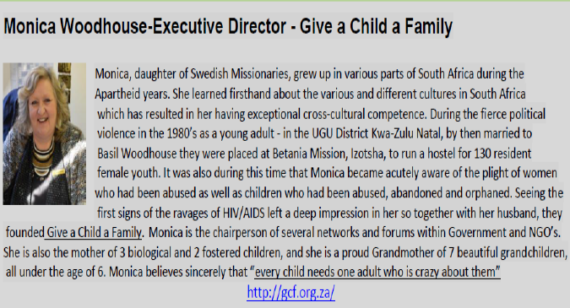

Give a child a family (GCF) – ORGANISATIONAL DESCRIPTION www.gch.org.za
- GCF operates from the conviction that children have the right to grow up in a family and this principle is embedded in their vision.
- GCF is a non-profit organisation that primarily works in the Ugu district in KZN and in several countries in the Eastern and Southern African region.
- GCF is a child care and protection organisation that employs a holistic, eco-systemic approach to ensuring the care and protection of vulnerable children. Children need strong, effective and responsive circles of support at each of the levels, from family, to community, through to enabling policies and systems to create the conditions necessary for them to enjoy their rights to a family, to survive, be protected and develop to their full potential.
- Give a Child a Family runs a temporary care facility for 60 children aged birth to 12 years of age.

From Monica’s experience:

Usually, it is Parents who need Help and not the child.
First Case in point:
- Children who are in institutions suffer broken promises of parents who say they will visit but then they don’t. It is traumatizing for those children and heartbreaking to see them wait. Parents don’t realise the amount of damage that does to a child.
Second Case in point:
- An 8-year-old displays deviant sexual behavior. State takes him away. He is put into a CYCC. There he contracts TB, HIV Aids and dies.
NB: We have all failed these children.
A family is what a child need!

BEFORE WE PUT A CHILD INTO A CYCC, WE NEED TO LOOK AT ALTERNATIVE SOLUTION.
EVERY CHILD NEEDS AT LEAST 1 ADULT WHO IS CRAZY ABOUT THEM!

Point to ponder:
We have to have a license to drive a car which is an object with zero feelings.
We go for driving lessons and we have to pass the test.
How ironic is it, that we don’t have to have a license to be a parent and raise a child?

With GCF’s Re-integrations program, 55% of the children they work with are back with their families.

Foster-Care: GCF enters communities via schools, churches etc and spreads the word that they are looking for parents to foster-Care. In rural places especially amongst the African people, there is a much stronger pull to foster-care. The procedure can take between 6- 9months before the family is approved. If there are children in that family that’s over 18yrs of age they must also be screened.
If the family is approved, the child is gradually disengaged from the CYCC and gradually engaged with the family. This prevents any further trauma as the child will eventually ask to stay with the family and not want to come back to the CYCC.
GCF mentors and supports the family that fosters the child. The family also enters into a support group for 2 years with ongoing assessments and further training for the foster parents to build them up. All foster parents and children gather for an annual event, which creates that spirit of connectedness.

GCF trains about 350 families a year. The Parenting for Life Course consists of the following modules:
- Coping with death and trauma
- Healthy living – physical, emotional, spiritual
- Support groups with a 2 yr mentorship
- Protective Behaviours – of which 9000 scholars / teachers have been reached
- Child watch committees.

- QUESTIONS AND ANSWERS
Question: How does it work with race and area, be it rural or urban?
Answer: GCF doesn’t look at race but we look at social economics etc. Bringing a child into a family does change the dynamics and the fathers must be included. We are always cognizant of the best interest of the child.
We do the following 4 steps: 1. Clearances
2. Assessments of prospective foster parents
3. Visitation
4. Sessions with the child

Question: Would this module work in the Western Cape with its high drug and gang infested areas? Wouldn’t families just foster care for the money as we have often seen happen?
Answer: With proper screening, support and follow up, it should work. It’s a long procedure and in that time, we access whether the family’s heart is in the right place. We might not have the same rate of success as in the other African countries but we can help the foster families with death and trauma, then that’s a start. Social Workers need to be connected, which is key. So Yes, it is workable.

“Observation regarding foster care in South Africa.
So often we have found Grandparents who are willing to foster their grandchildren because the Mom was on drugs etc. has disappeared - but then SASSA proceeds to take away the children’s grants because the Grandparents are employed. This doesn’t make sense and this is happening so often.”

Question: Can anyone access the services of GCH?
Answer: GCF is willing to assist and train. We are currently looking at office space in Western Cape.
We have the following training programs: Baseline and 8 modules:
- 4.5 days foster care programs
- Coping with death and trauma
- 1.5 days Social justice level 1
- Training of facilitators

Question: May foreigners foster care?
Answer: Not in SA unless they have permanent residency.
NB: By rights, any foreign child should be treated as children of another country with regards to the many children’s charters. They should be given a temporary ID so that they can continue their education and attend school etc.

Point to ponder: We should have a separate office that deals with the RIGHTS OF A CHILD and not one affiliated with any political party. It would be great if DSD could just look after the social aspect.

Monica to make available the presentation.

- NEXT MEETING in 2020 to be announced.

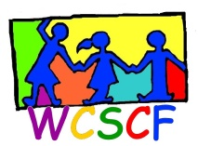
WCSCF ALL REGIONS GATHERING
Wednesday, 26th February 2020
10am – 12noon @ Salesians Hall, Green Point

AGENDA

- Coffee and Networking

- Welcome, Apologies & Introductions

- Guest Speaker:
Rochshana Kemp, WCED Social Work Manager
On SIAS Process at Schools

- Questions and Answers on SIAS

- Other Matters
a.
b.

- Next Meetings:
  - Northern Suburbs Sub-Forum – 5th March
  - Hout Bay Sub-Forum - 10th March
  - “Get it Right” Schools Law on Disciplinary Hearings, Suspensions and Expulsions – TBA
  - Lavender Hill /Vrygrond Sub-Forum - TBA
  - CNOYO Gathering – 26th March
  - All Regions Meeting – 28th May

- More Coffee and Networking

Enquiries: Janice King (WCSCF Coordinator)
Cell: 072 4500 456 Email: wcstreetchild@gmail.com

