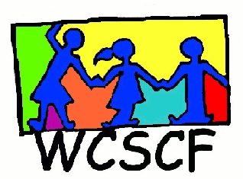
Northern Suburbs Street Children’s Meeting
1 October 2015
9:30 - 11:30
Durbanville Council Chambers
__________________________________________________________________________________
Present: Wilma Piek (VRCID), Dick Smith (DSD Metro North), Juanita Beukes (Badisa Trio), Benjamin Martin (DSD), Lionel Klassen (Catholic Church), Peter Lourens (Law Enforcement), Stacey Doorly-Jones (2nd Chance), Vanessa Brink (Badisa), Ruth Tshabangu (Private), Lucinda Valentine (WCSCF) and Janice Sparg (WCSCF).
Apologies: Hewitt De Jager (HewLin Compassion), Cassie van Zyl (BBID), Leon Brynard (VCID), T. Kopele (DSD Kraaifontein), Mrs Marais (DSD Kraaifontein), Wendy Bosse (Olympians), Caretha Randall (Badisa), Pamela Venter (Kraaifontein Patrols) and Jenny Bester (Communicare).

- Welcome and introductions
Janice welcomed all present and thanked them for coming. Introductions went around the room.
Minutes of last meeting proposed by Janice and seconded by Lucinda Valentine.

- Any other business

- Meetings for the rest of the year - see dates and venue below
Thursday, 29th October - Durbanville Council Chambers 9:30am-11:30am
26th November - Durbanville Council Chambers

Please diarise and set aside. We need your partnership in this process.

Enquiries: Janice Sparg (WCSCF Coordinator)
Cell: 072 4500 456
Email: wcstreetchild@gmail.com

